**STUDENT ASSESSMENT SUBMISSION AND DECLARATION**

When submitting evidence for assessment, each student must sign a declaration confirming that the work is their own.

|  |  |  |  |
| --- | --- | --- | --- |
| Student Name: Mg Kaung Htike San | | Assessor name: Ayesha Shariff | |
| Issue date:  23 Feb, 2023 | Submission date:  27 Feb, 2023 | | Submitted on:  27 Feb, 2023 |
| Programme: BTEC Level 5 Higher National Diploma in Computing – Application development RQF | | | |
| Unit: Front-end Development | | | |
| Assignment title: ABC Learning Centre | | | |

**Plagiarism**

Plagiarism is a particular form if cheating. Plagiarism must be avoided at all costs and students who break the rules, however innocently, may be penalized. It is your responsibility to ensure that you understand correct referencing practices. As a university level student, you are expected to use appropriate references throughout and keep carefully detailed notes of all your sources of materials for material you have used in your work, including any material downloaded from the Internet. Please consult the relevant unit lecturer or your course tutor if you need any further advice.

**Student Declaration**

|  |
| --- |
| **Student declaration**  I certify that the assignment submission is entirely my own work and I fully understand the consequences of plagiarism. I understand that making a false declaration is a form of malpractice.  Student signature:  Date: 17 Feb, 2023 |

Contents

Change the product price based on the currency selected. 2

Create your own json file for currency conversion 5

Read the product page using the Server-Side Script. 10

Display it in the main content area of the demo products page. 15

Configure Apache to use Single IP Address (your local IP Address) to host 24

Defining the document root as below 26

Deploy the application and capture the screenshot as below 27

**Developing single page application**

# Change the product price based on the currency selected.

In the product price, we have selection on the national currency; Singapore, Malaysia, India, Philippine & Indonesia. The currencies will change depending on the selection.

If the user clicks “Singapore Dollar” the program will show Singapore currency.

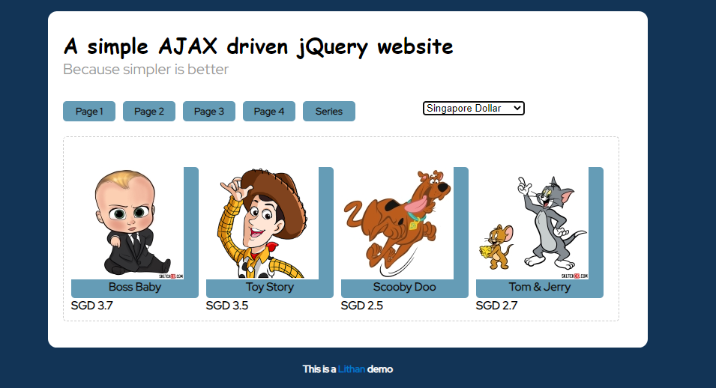

If the user clicks “Malaysian Ringgit” the program will show Malaysian currency.

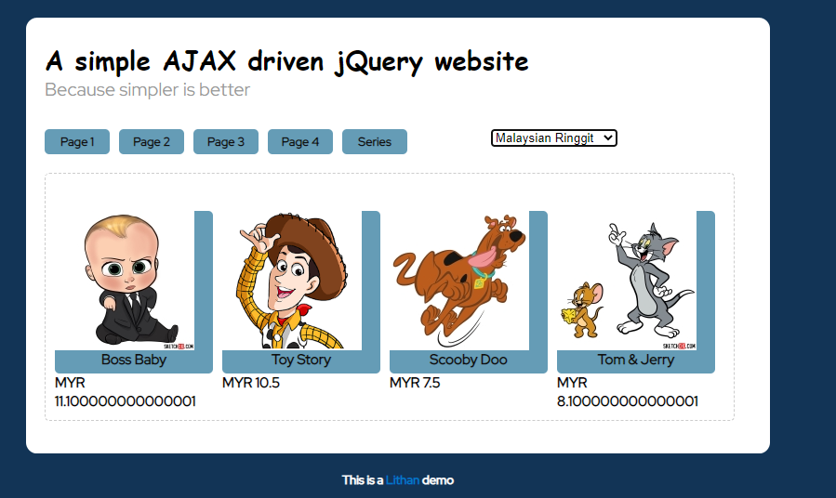

If the user clicks “Indian Rupees” the program will show Indian currency.

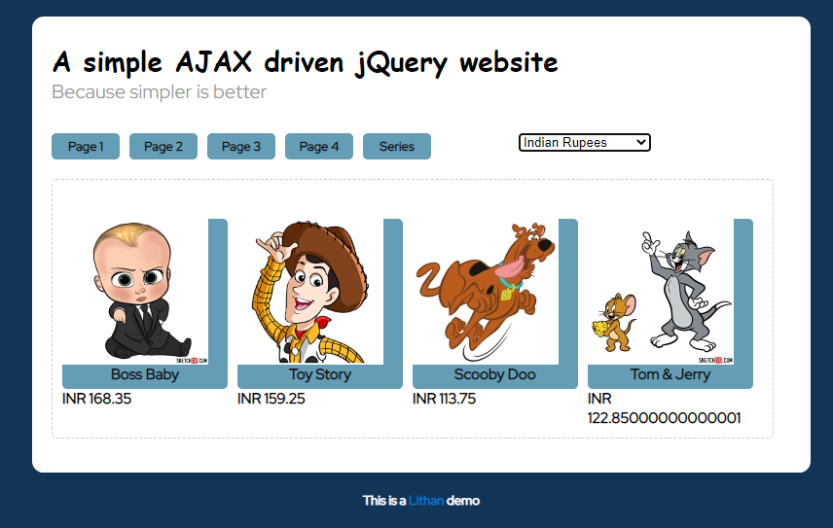

If the user clicks “Philippine Peso” the program will show Philippine currency.

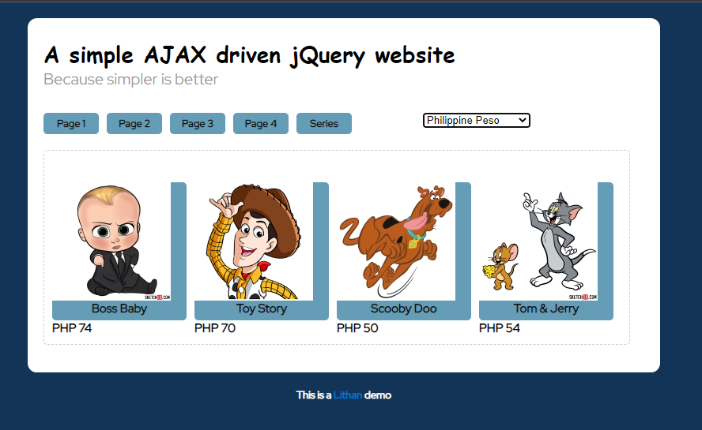

If the user clicks “Indonesian Rupiah” the program will show Indonesian currency.

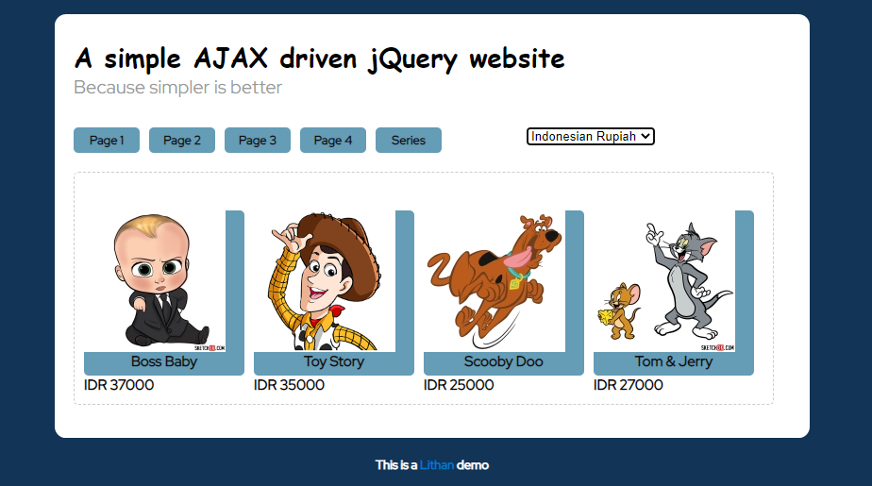

# Create your own json file for currency conversion

I make currencies.json to make the currency depending on the user’s selection.

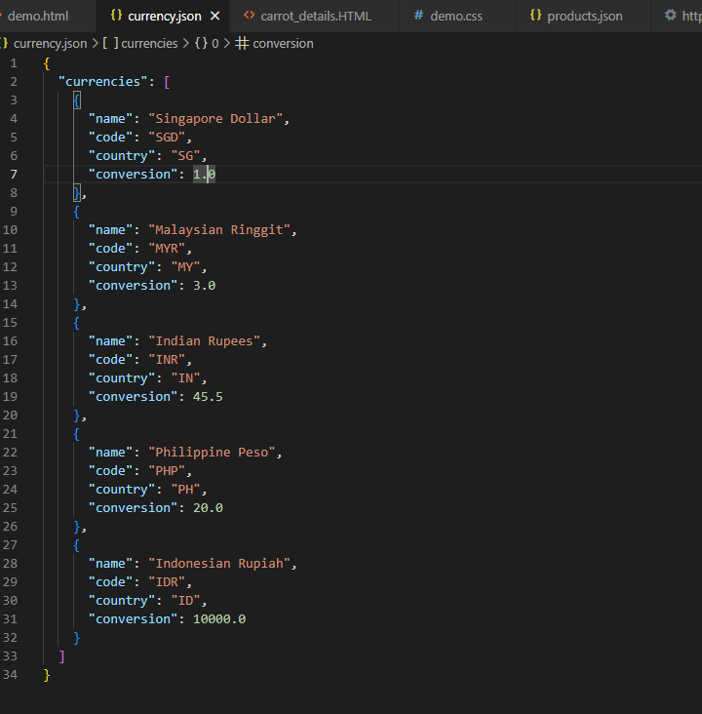

1. **Call a Server-Side Script with product Id.**

We create demo.html and create products.json and connected with details page.

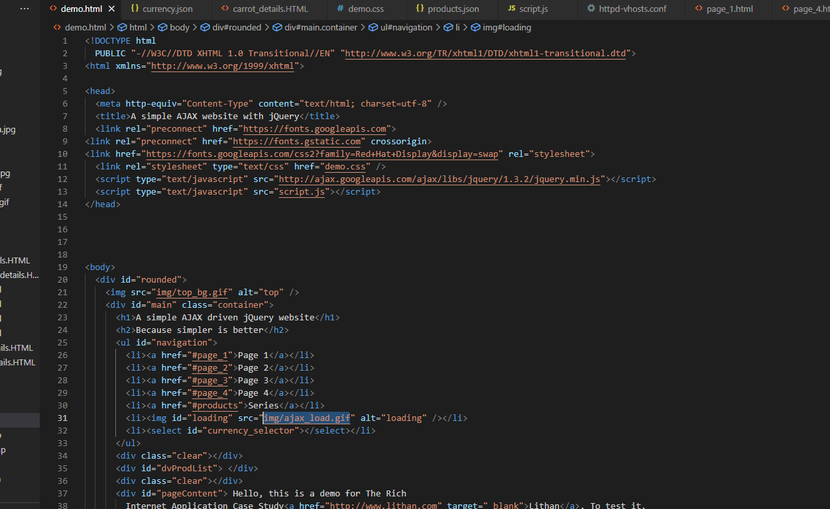

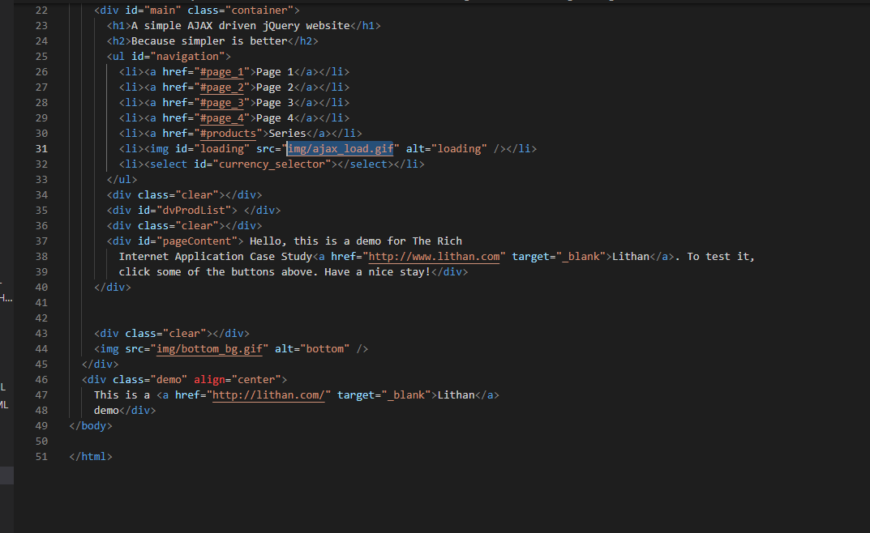

products.json

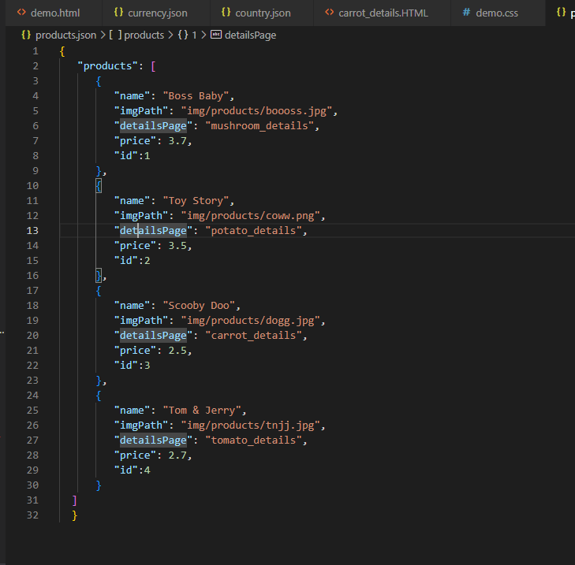

Details pages

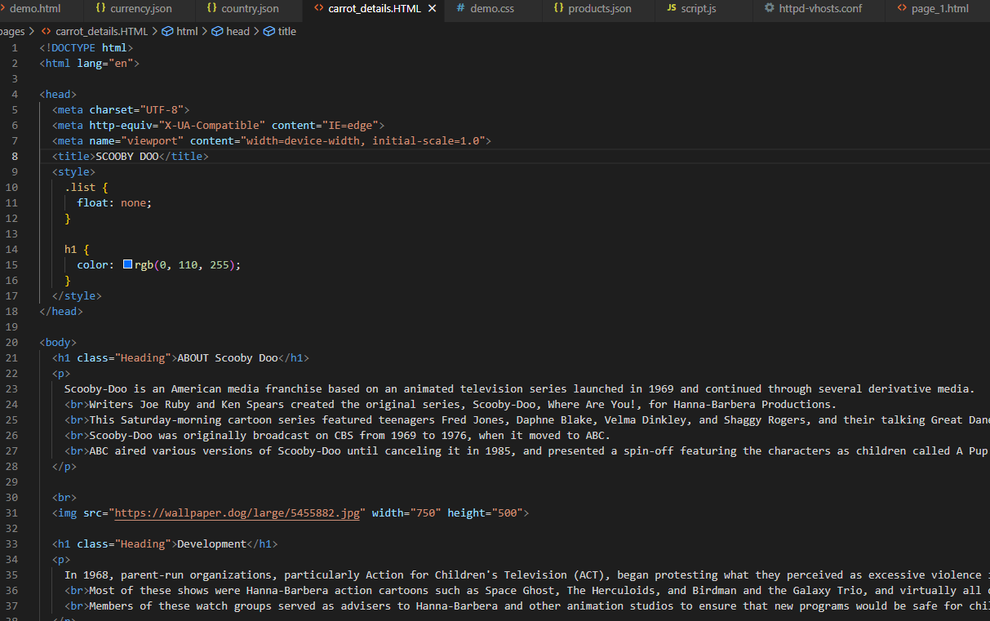

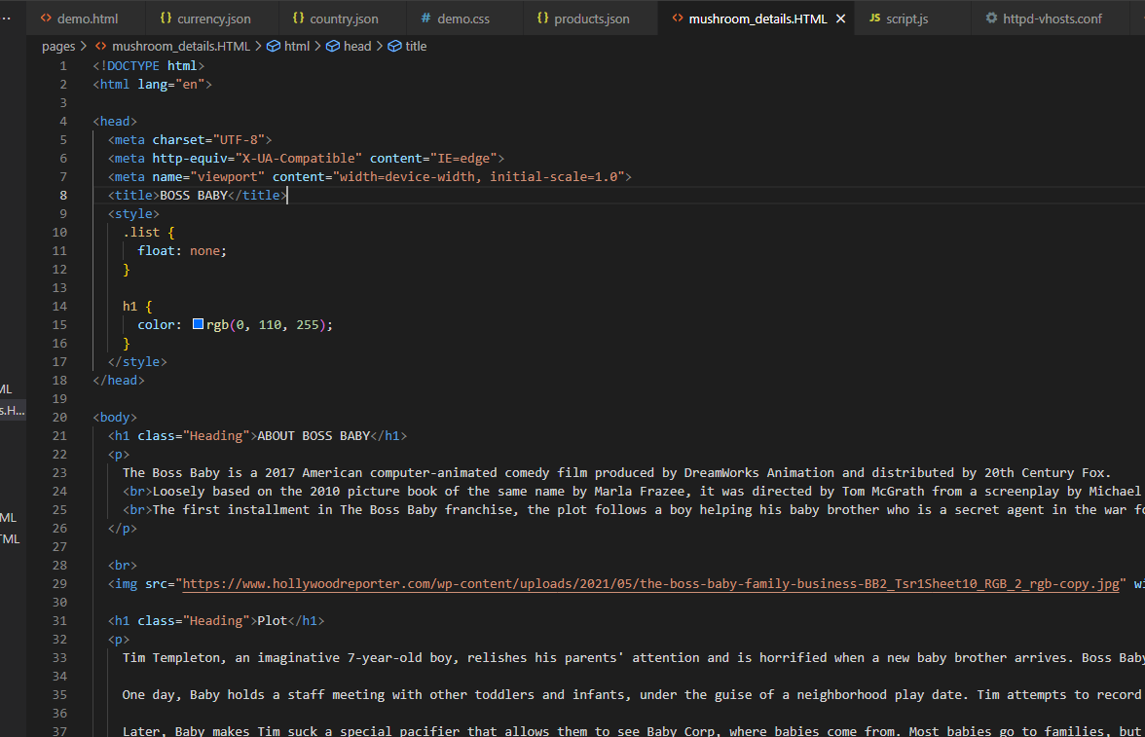

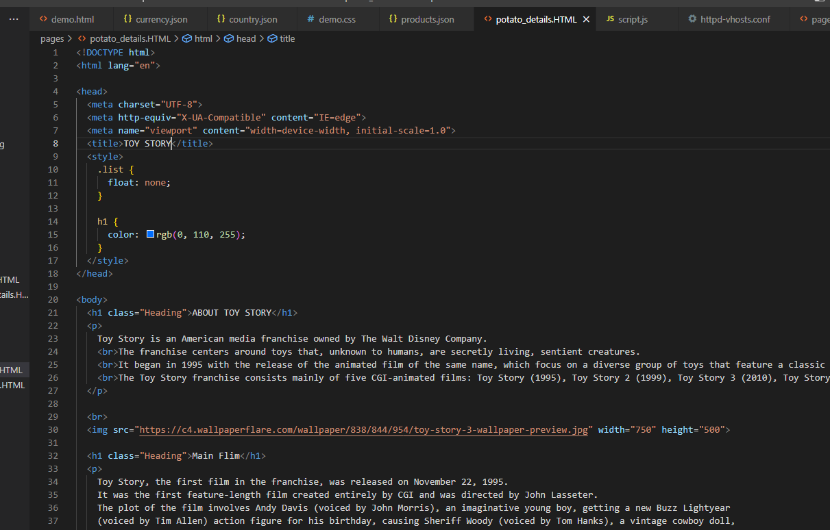

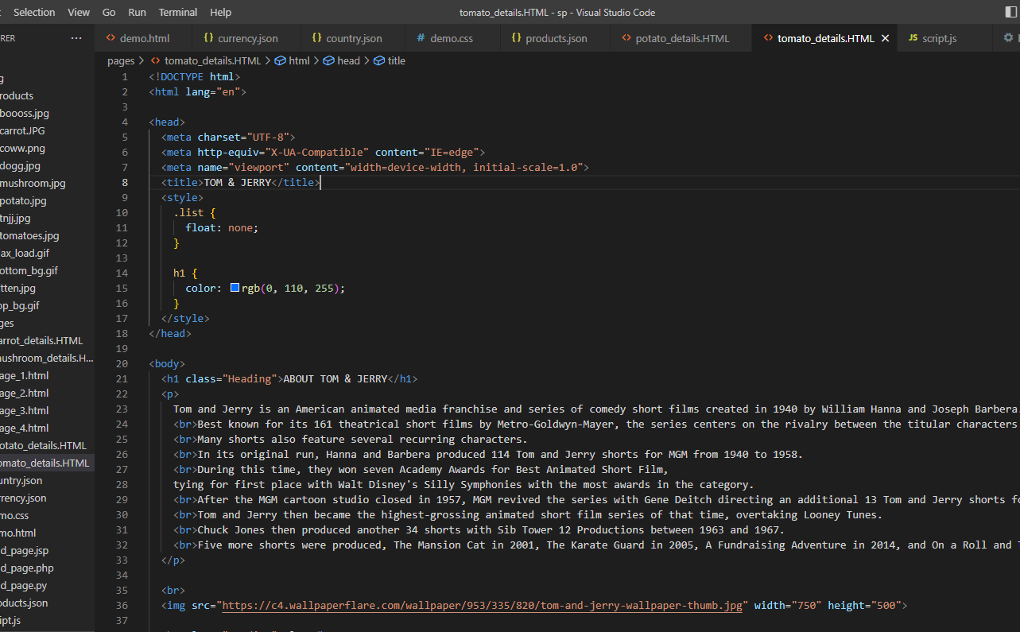

# Read the product page using the Server-Side Script.

Use the Server-Side Script to read the product page.

Details pages









products.json

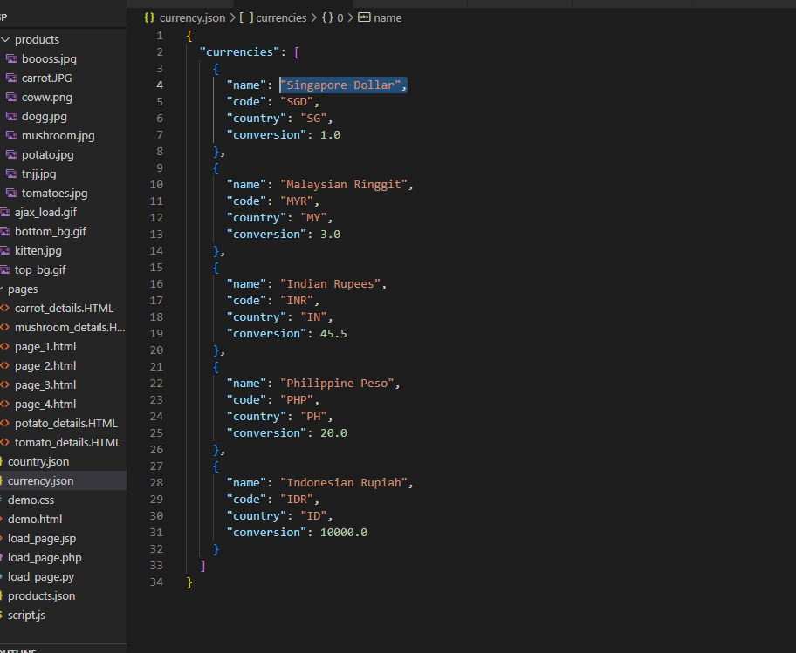

In script.js

We calculate the currency.

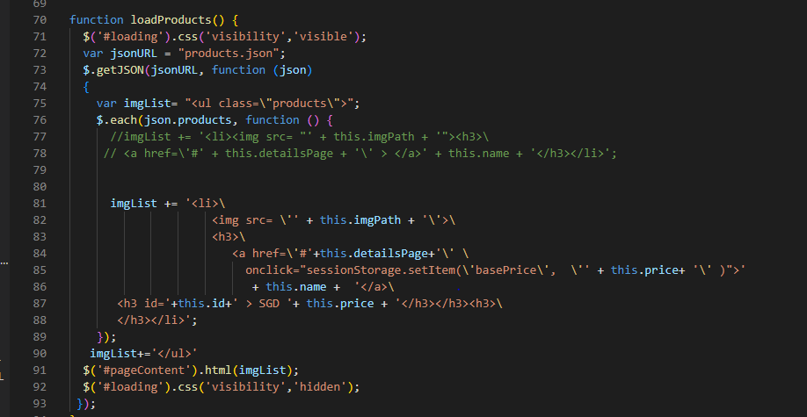

Load_page.php

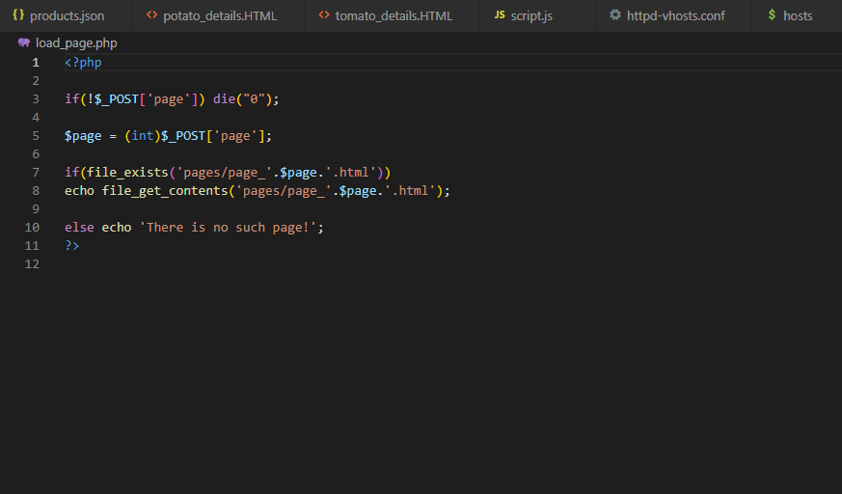

# Display it in the main content area of the demo products page.

Main Content

In the following page, four buttons are added and the image I described is for services. In following, when we click the letter beneath the image, it will go to the respective position.

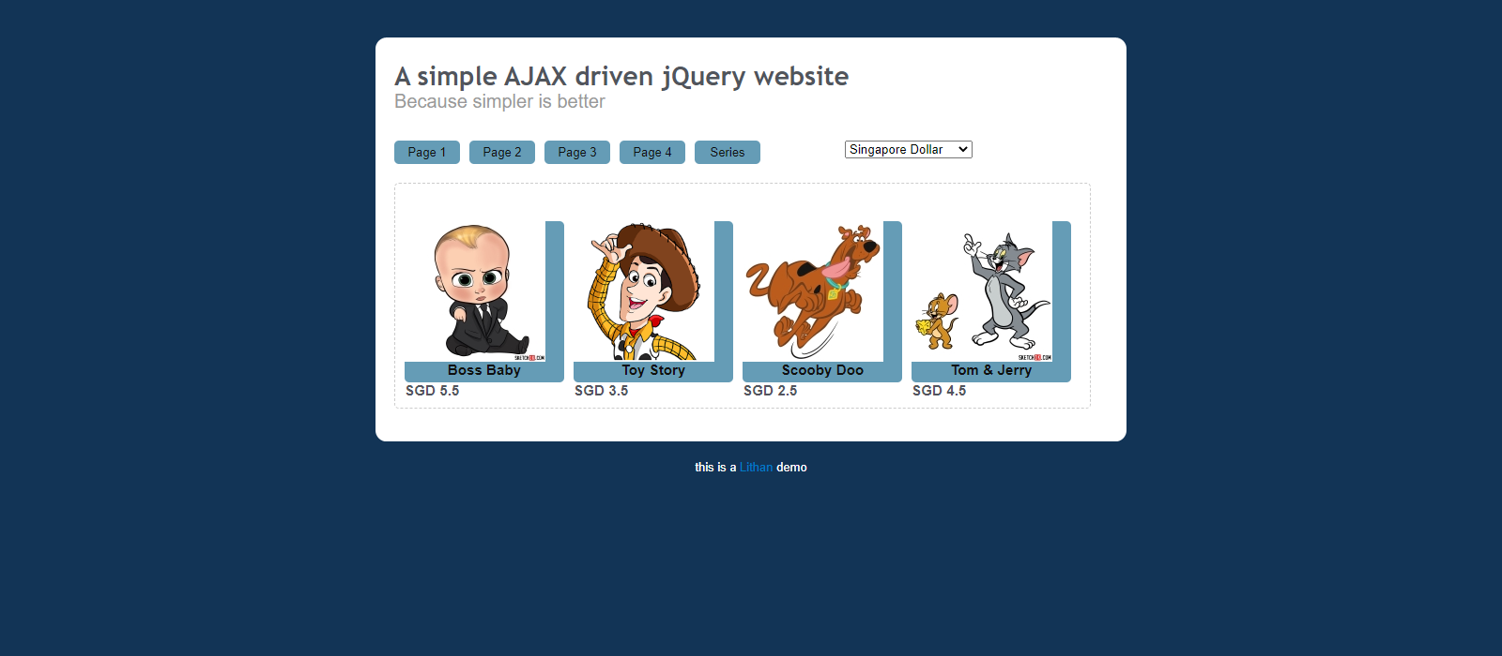

Boss baby

When we click the “Boss Baby” beneath the boss baby image, we will get to the Boss Baby one.



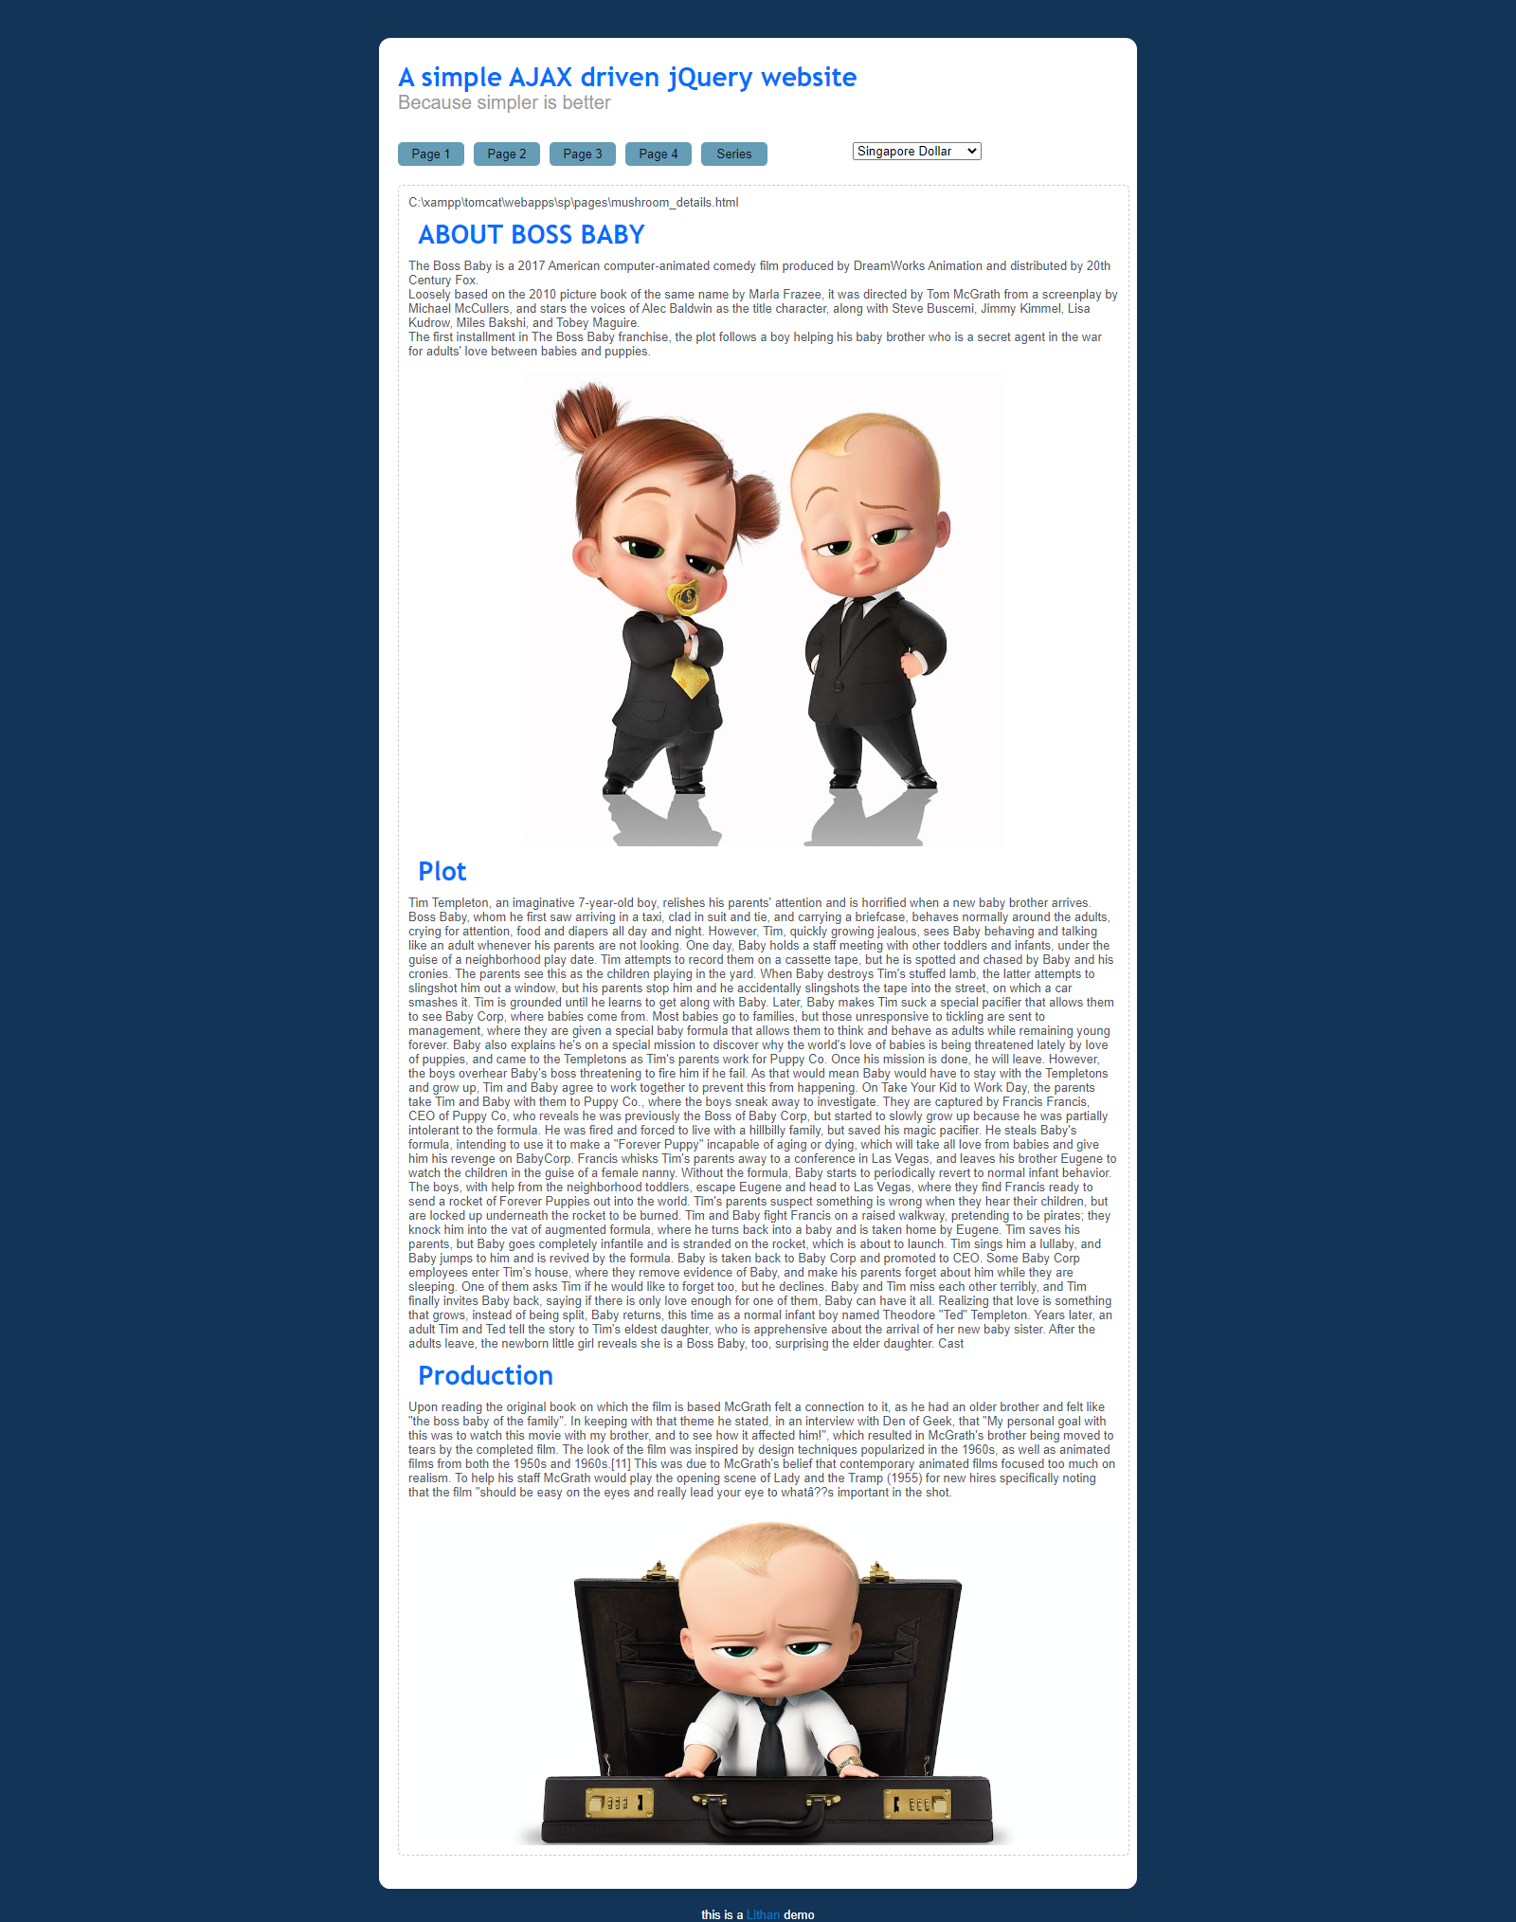

Toy story

When we click the “Toy Story” beneath the Toy Story image, we will get to the Toy Story one.



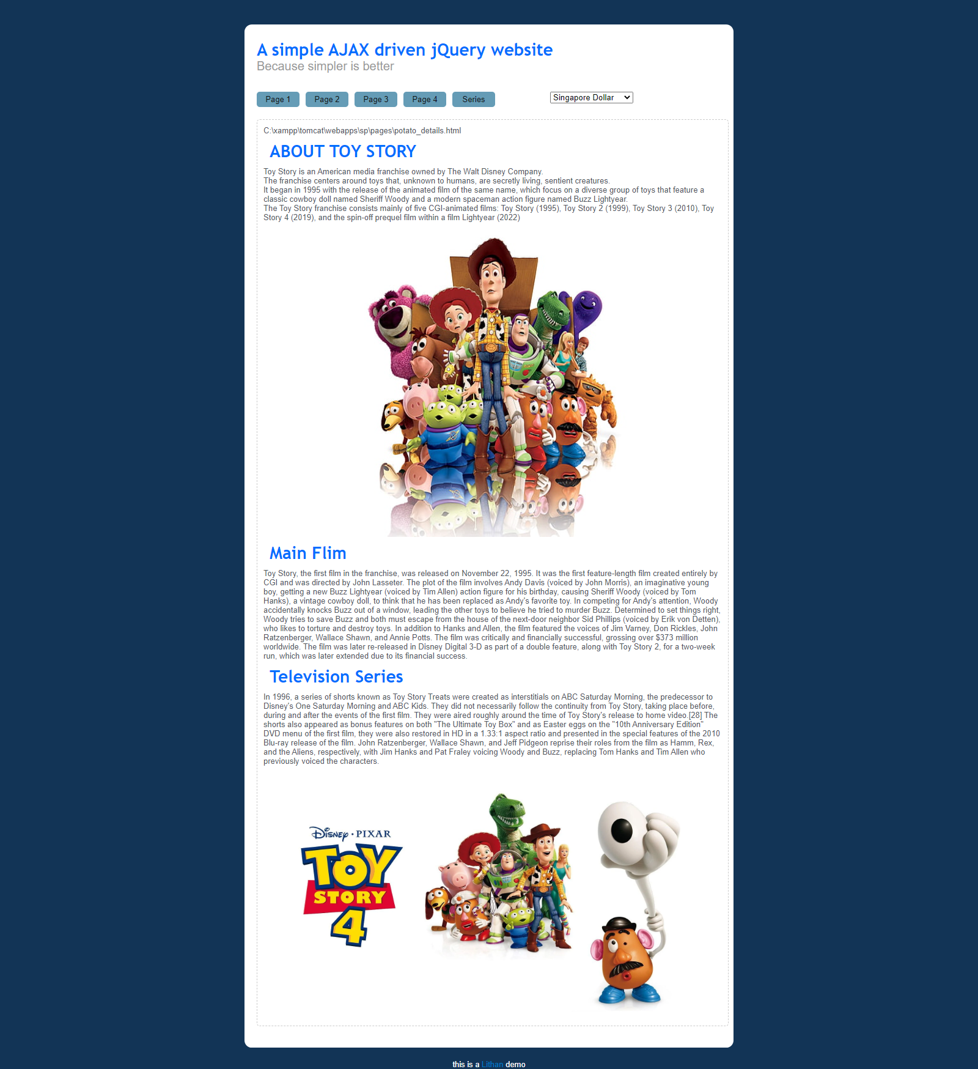

Scooby Doo

When we click the “Scooby Doo” beneath the Scooby image, we will get to the Scooby Doo one.



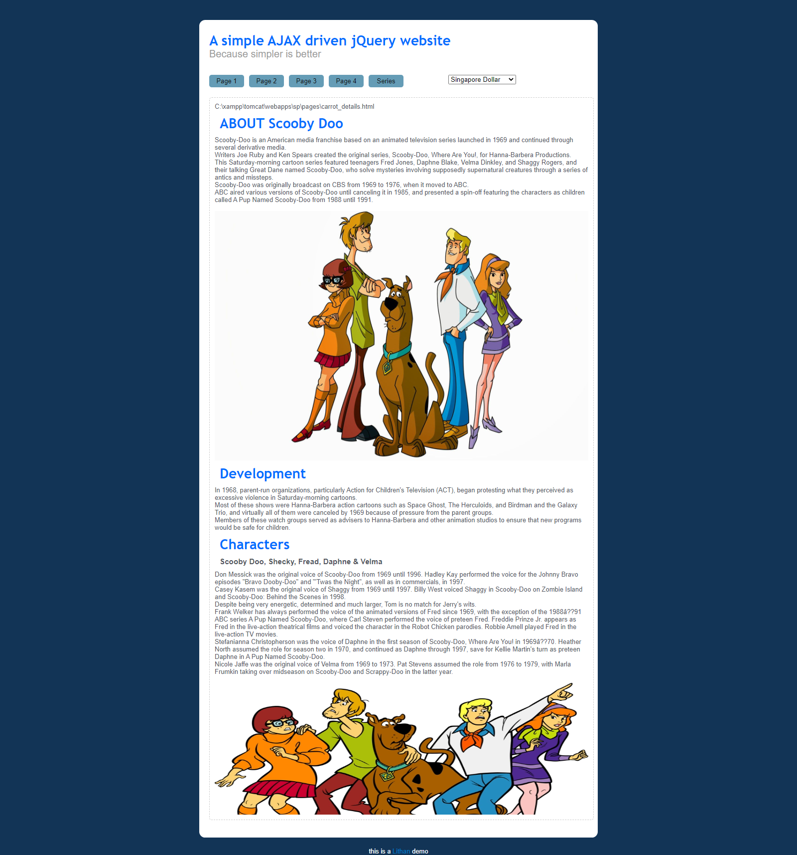

Tom & Jerry

When we click the “Tom & Jerry” beneath the Tom & Jerry image, we will get to the Tom & Jerry one.



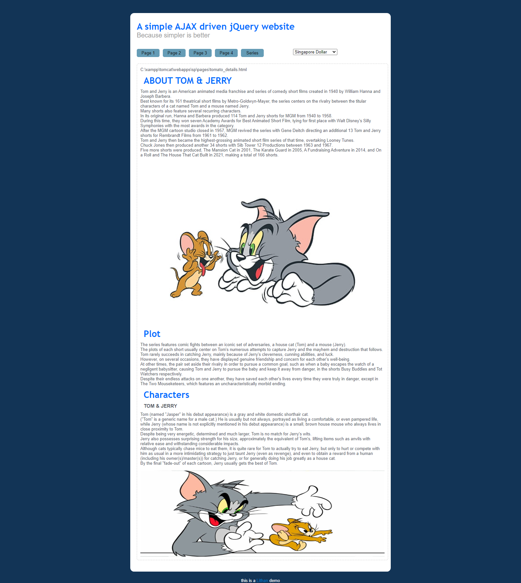

# Configure Apache to use Single IP Address (your local IP Address) to host

The local IP Address is changed according to my student No and used Apache to with as a domain. I created 2 html files and linked with Apache and run the program and the following happens.

For page 2

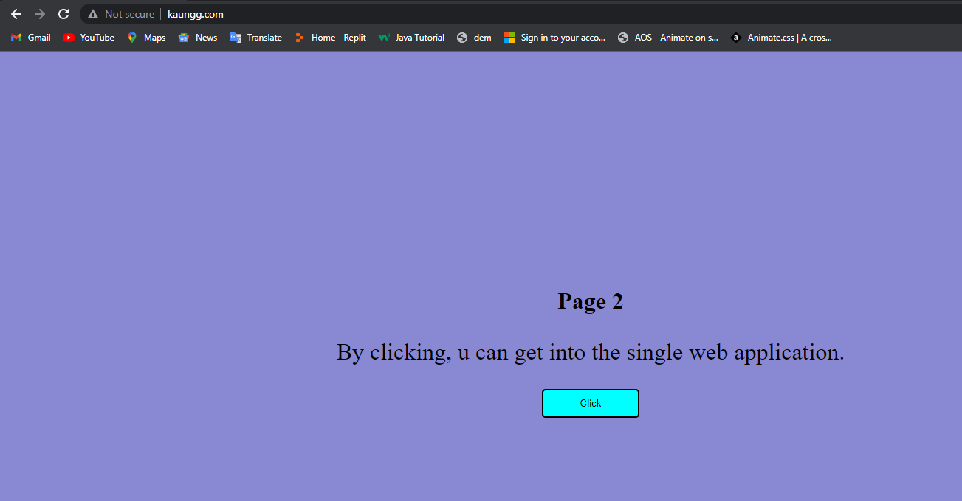

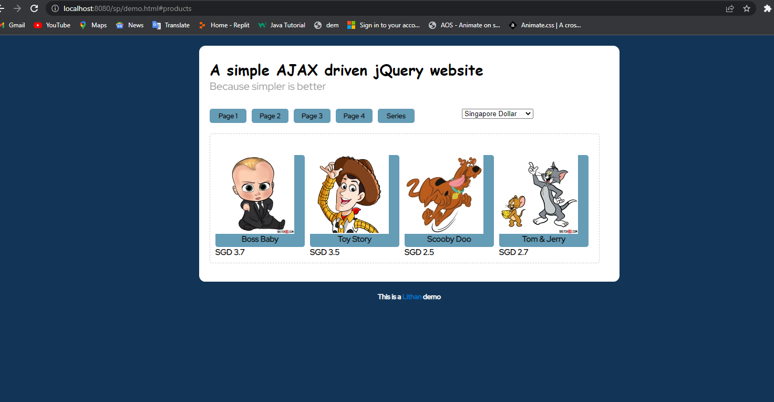

For page 1

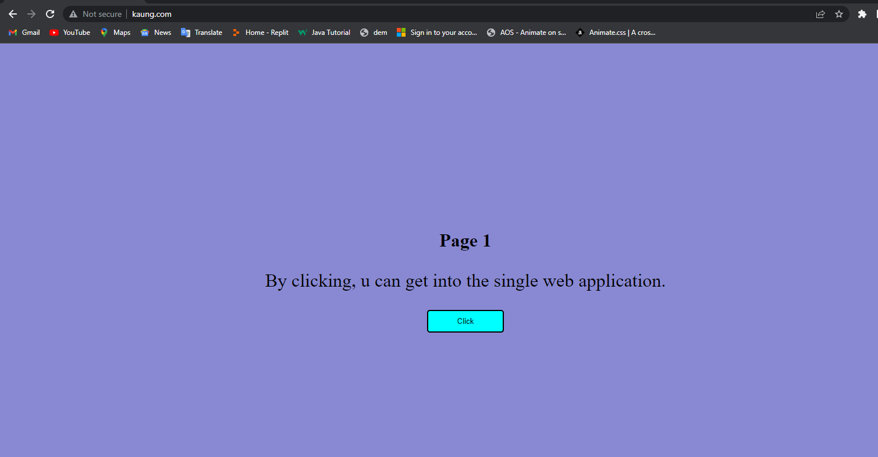



# Defining the document root as below

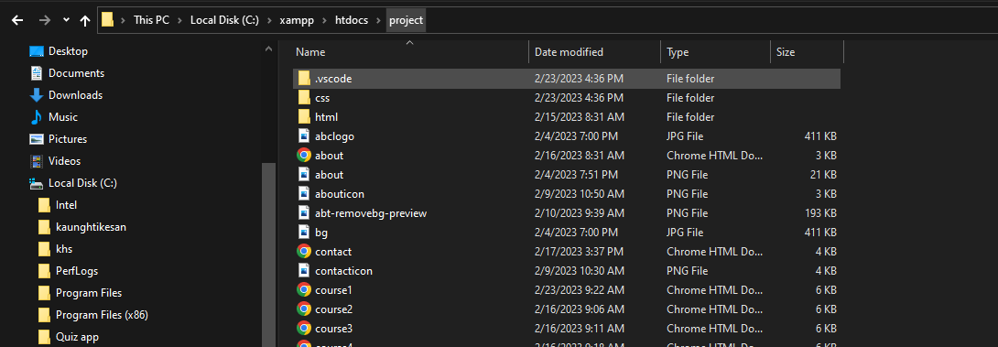

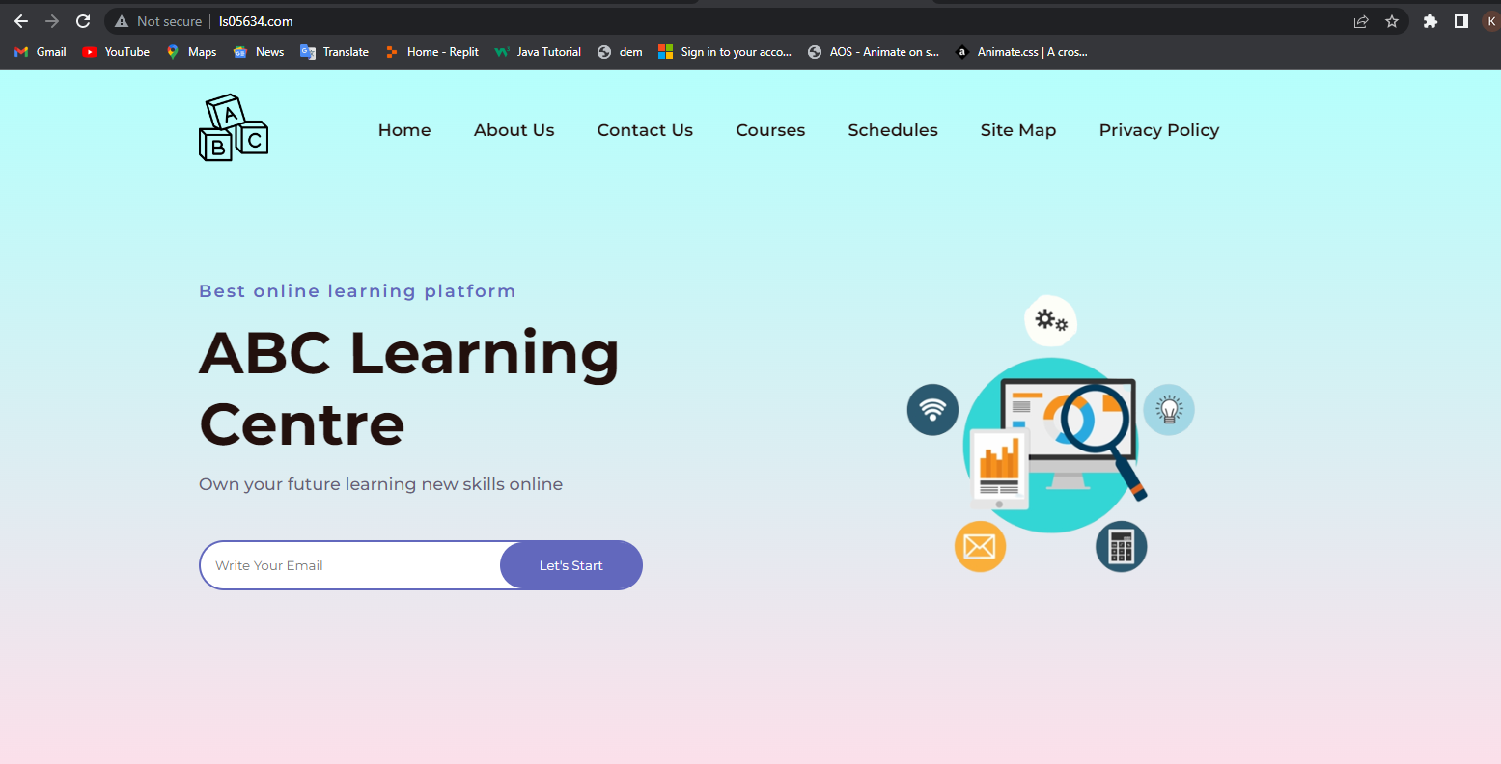

# Deploy the application and capture the screenshot as below

